Abstract

This is the user manual for the program Mail-IT.

User guide

By Matthew Karko

# User Guide

Before you open the program, open the details.txt file that will give you login details that you well need in order to access the programs interface. This is done for security purposes.

After that launch the program.

You will be greeted with this screen:

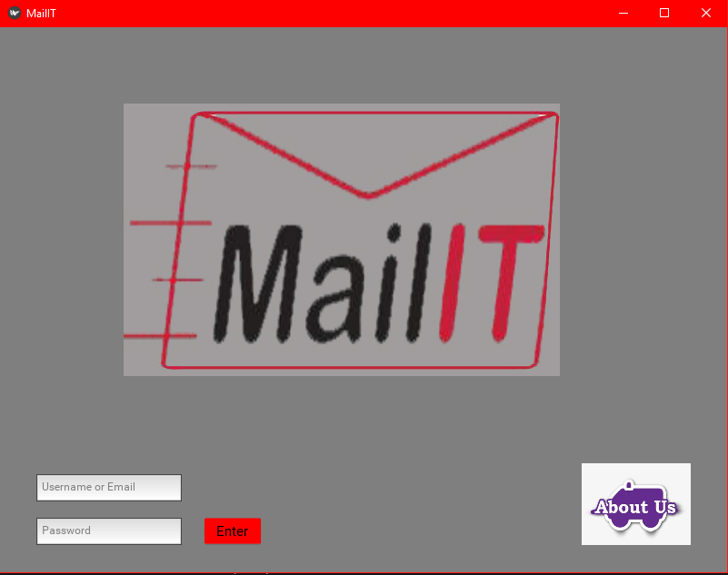

What you need to do is type the details that are provided into the correct text inputs. Once you have entered the correct inputs, press enter, and it will take you to the email page. However, if you would like to visit the about page just press on the ABOUT US icon.

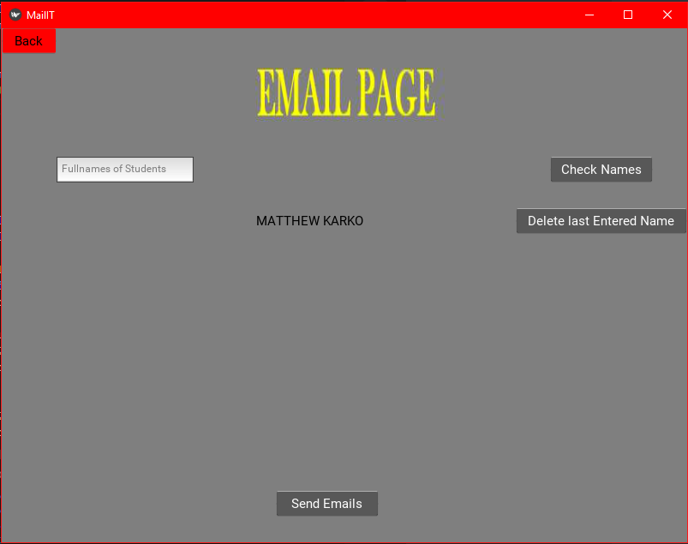

On this page what you want to do is enter the names of the students into the provided text input box. Then they will appear on the middle of the screen as shown. After your list is entered you can check names on the right-hand side as shown and you can also remove the last entered name. If you would like to go back to the login page and check out the about page you can do so by pressing the back button displayed on the top left corner.

Once your name list is ready, you can press the send emails button and a pop up like this will show up. And if it is ready just press yes and the emails will be sent. If the names are correct, then press yes to send the email. If not just press no and fix the error.

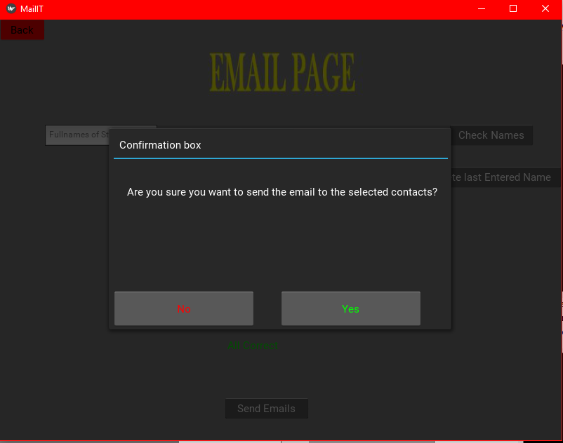

After this the program will notify you if the emails have been sent or if they have failed to send.

If you need any help please contact us on:

* Mailit.com.au/help
* [mailit@gmail.com](mailto:mailit@gmail.com)
* (02) 9999 9999